Day -5

Problem statement 1
Create a new Java project with "AddressDetails.java" file and implement a Java code to display your address.

Sample Output
Door No: D203
Street: St. Louis Street
City: New Delhi
ZIP Code: 123456

Problem Statement 2 :
Create a new Java project with "TraineeDetails.java" file and implement a Java code to display your name and designation in two separate lines.

Sample Output
My name is Maria Jerome.
My designation is Systems Engineer.
Problem stmt 3
Implement a program to calculate the Simple Interest by using the formula given below and display the calculated Simple Interest.
Simple Interest = (principal*rate of interest*time)/100

Sample Input and Output
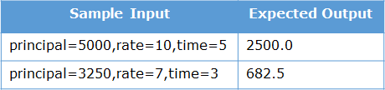
4)
Implement a program to find the area of a circle by using the formula given below and display the calculated area.
Area = pi*radius*radius
The value of pi is 3.14.

Sample Input and Output
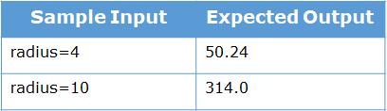

5) Implement a program to find and display the maximum number out of the given three numbers.

Sample Input and Output
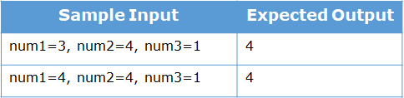
6)
Implement a program to calculate the factorial of a given number.

Sample Input and Output
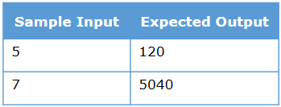
7)
Implement a program to display the geometric sequence as given below for a given value n, where n is the number of elements in the sequence.
1, 2, 4, 8, 16, 32, 64, ......, 1024

Sample Input and Output
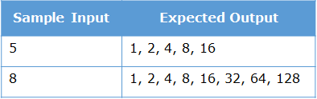
8)
Implement a program to calculate the product of three positive integer values. However, if one of the integers is 7, consider only the values to the right of 7 for calculation. If 7 is the last integer, then display -1.
Note: Only one of the three values can be 7.

Sample Input and Output
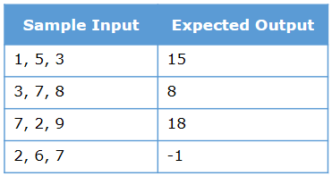
9) Food Corner home delivers vegetarian and non-vegetarian meals to its customers based on the order.
A vegetarian combo costs $12 per plate and a non-vegetarian combo costs $15 per plate. Apart from the cost per plate of food, customers are also charged for home delivery based on the distance in kms from the restaurant to the delivery point. The delivery charges are as mentioned below:
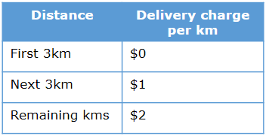
10) Given the type of food, quantity (no. of plates) and the distance in kms from the restaurant to the delivery point, implement a program to calculate the final bill amount to be paid by a customer.
The below information must be used to check the validity of the data provided by the customer:
- Type of food must be 'V' for vegetarian and 'N' for non-vegetarian.
- Distance in kms must be greater than 0.
- Quantity ordered should be minimum 1.
If any of the input is invalid, the bill amount should be displayed as -1.

Sample Input and Output
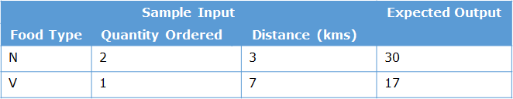

11) The Metro Bank provides various types of loans such as car loans, business loans and house loans to its account holders, i.e., customers.
Implement a program to determine the eligible loan amount and the EMI that the bank can provide to its customers based on their salary and the loan type they expect to avail.
The values required for determining the eligible loan amount and the EMI are:
- account number of the customer
- account balance of the customer
- salary of the customer
- loan type
- expected loan amount
- expected no. of EMIs
The following validations should be performed:
- The account number should be of 4 digits and its first digit should be 1
- The customer should have a minimum balance of $1000 in the account
Display appropriate error messages if the validations fail.
If the validations pass, determine whether the bank would provide the loan or not.
The bank would provide the loan, only if the loan amount and the number of EMIs expected by the customer is less than or equal to the loan amount and the number of EMIs decided by the bank respectively. The bank decides the eligible loan amount and the number of EMIs based on the below table.
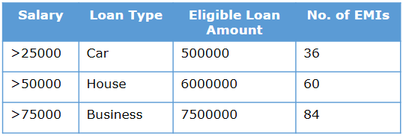
Display the account number, eligible and requested loan amount and the number of EMIs if the bank provides the loan.
Display an appropriate message if the bank does not provide the loan.

Sample Input and Output
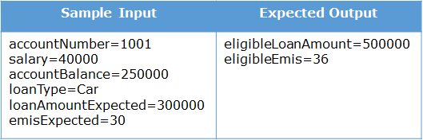

11) You have x number of $5 notes and y number of $1 notes. You want to purchase an item for amount z. The shopkeeper wants you to provide exact change. You want to pay using a minimum number of notes. How many $5 notes and $1 notes will you use?
Implement a program to find out how many $5 notes and $1 notes will be used. If an exact change is not possible, then display -1.

Sample Input and Output
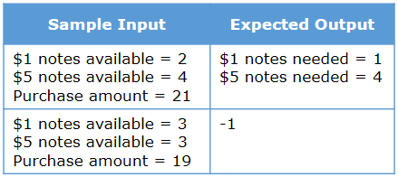
12)Implement a program to generate and display the next date of a given date.
The date will be provided as day, month and year as shown in the below table.
The output should be displayed in the format: day-month-year.
Assumption: The input will always be a valid date.

Sample Input and Output
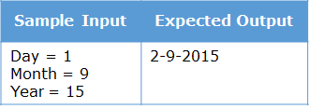

13)Implement a program that displays a message for a given number based on the below conditions.
- If the number is a multiple of 3, display "Zip".
- If the number is a multiple of 5, display "Zap".
- If the number is a multiple of both 3 and 5, display "Zoom",
- For all other cases, display "Invalid".

Sample Input and Output
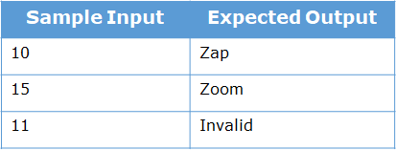

14)Create a new class Food in the Java project SwiftFood with the details given below.
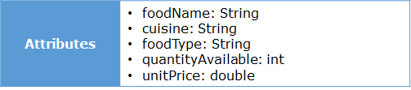
Test the functionalities using the Tester class.
15) Implement a class Calculator with the method mentioned below.
Method Description
findAverage()
- Calculate the average of three numbers
- Return the average rounded off to two decimal digits
​​​​
Test the functionalities using the provided Tester class.

Sample Input and Output
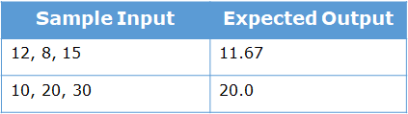

Hint: For round-off to two decimal digits:
double num1 = 65, num2 = 175;
double num3 = num1/num2;
System.out.println(Math.round(num3*100.0)/100.0);
16)
SwiftFood also provides the feature for non-registered customers to order food. Add one more constructor to the Customer class to implement this functionality.
Method Description
Customer(String customerName, long contactNumber, String address)
- Initialize the customerName, contactNumber and address instance variables appropriately with the values passed to the constructor.
Create an object of the Customer class by using the parameterized constructor and display the customer details by invoking the displayCustomerDetails() method in the main() method of the Tester class.

Sample Output
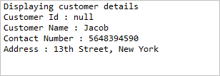
17) Problem Statement
Create a new class Order in the Java project SwiftFood with the instance variables and methods mentioned below.
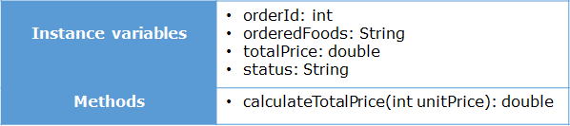
Method Description
calculateTotalPrice(int unitPrice)
- Calculate the total price by applying a service charge of 5% on the food item ordered and store it in the instance variable totalPrice.
- Return the calculated total price.
Create an object of the Order class, initialize the instance variables, invoke the calculateTotalPrice() method and display the values of the instance variables in the main() method of the Tester class.

Sample Output
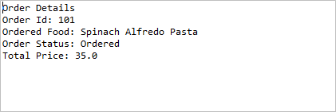
18) Problem Statement
Create a new class Restaurant in the Java project SwiftFood with the instance variables and methods mentioned below.
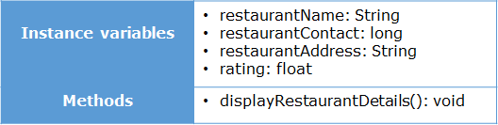
Method Description
displayRestaurantDetails()
- Display the details of the restaurant (the values of the member variables)
Create an object of the Restaurant class, initialize the instance variables, and invoke the displayRestaurantDetails() method in the main() method of the Tester class.

Sample Output
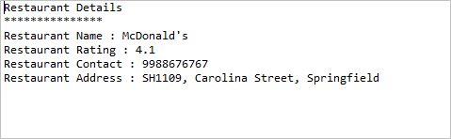

19) Problem Statement
SwiftFood also provides the feature for non-registered customers to order food. Add one more constructor to the Customer class to implement this functionality.
Method Description
Customer(String customerName, long contactNumber, String address)
- Initialize the customerName, contactNumber and address instance variables appropriately with the values passed to the constructor.
Create an object of the Customer class by using the parameterized constructor and display the customer details by invoking the displayCustomerDetails() method in the main() method of the Tester class.

Sample Output

20) Problem Statement
Create a new class Order in the Java project SwiftFood with the instance variables and methods mentioned below.

Method Description
calculateTotalPrice(int unitPrice)
- Calculate the total price by applying a service charge of 5% on the food item ordered and store it in the instance variable totalPrice.
- Return the calculated total price.
Create an object of the Order class, initialize the instance variables, invoke the calculateTotalPrice() method and display the values of the instance variables in the main() method of the Tester class.

Sample Output


21) Problem Statement
Create a new class Restaurant in the Java project SwiftFood with the instance variables and methods mentioned below.

Method Description
displayRestaurantDetails()
- Display the details of the restaurant (the values of the member variables)
Create an object of the Restaurant class, initialize the instance variables, and invoke the displayRestaurantDetails() method in the main() method of the Tester class.

Sample Output

22) Problem Statement
Implement a class Calculator with the instance variable and method mentioned below.
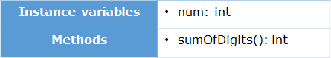
Method Description
sumOfDigits()
- Calculate and return the sum of the digits of the num member variable
Test the functionalities using the provided Tester class.

Sample Input and Output
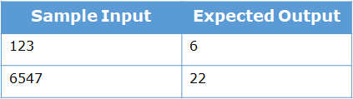
23) Implement a class Rectangle with the instance variables and methods mentioned below.
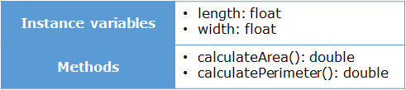
Method Description
calculateArea()
- Calculate and return the area of the rectangle. The area should be rounded off to two decimal digits.
calculatePerimeter()
- Calculate and return the perimeter of the rectangle. The perimeter should be rounded off to two decimal digits.
Test the functionalities using the provided Tester class.

Sample Input and Output
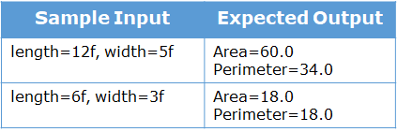
24) Modify the Order class created before and add two constructors in the class.
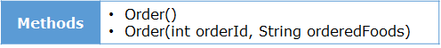
Method Description
Order()
- Set the value of status to 'Ordered'.
Order(int orderId, String orderedFoods)
- Initialize the instance variables appropriately with the values passed to the constructor.
- Set the value of status to 'Ordered'.
Create an object of the Order class by using the parameterless constructor and display the value of the status instance variable in the main() method of the Tester class.
Create one more object of the Order class by using the parameterized constructor and display the value of orderId, orderFoods and status instance variables in the main() method of the Tester class.

Sample Output
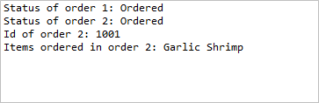
25) Modify the Restaurant class created before and add the below mentioned constructor.
Method Description
Restaurant(String name, long restaurantContact, String restaurantAddress, float rating)
- Initialize the instance variables appropriately with the values passed to the constructor.
Create an object of the Restaurant class and invoke the displayRestaurantDetails() method in the main() method of the Tester class.

Sample Output
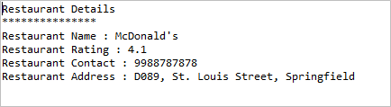
Day 5 ,6 :
Encapsulation :
26) Consider the class Employee given below for representing employees of an organization. It has 5 different instance variables and a method to calculate the total salary based on the jobLevel.
Salary is calculated in the calculateSalary() method.
Make necessary changes to the class by making all the attributes private and by adding necessary accessor and mutator methods thus bringing in Encapsulation.

27) Problem Statement
You have already created the Order and Food classes in the SwiftFood project.
Make necessary changes to the Order and Food classes by making all the instance variables private and adding getter and setter methods for the instance variables.
28) Implement the class MovieTicket with the instance variables and methods mentioned below.
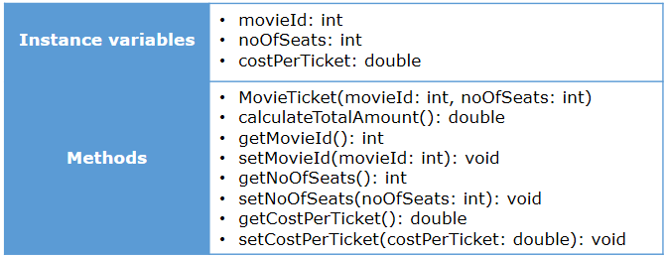
Method Description
MovieTicket (int movieId, int noOfSeats)
- Initialize the member variables movieId and noOfSeats appropriately with the values passed to the constructor.
calculateTotalAmount()
- Calculate the total amount to be paid based on the costPerTicket and noOfSeats by applying a 2% tax on the total amount.
- The costPerTicket for the movies are provided in the below table. Set the value of costPerTicket instance variable appropriately.
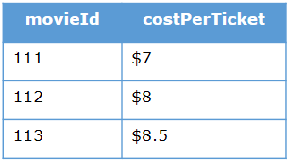
- Note: Return the total amount calculated after rounding off using the Math.round(double a) method.
Test the functionalities using the provided Tester class.

Sample Input and Output
Input
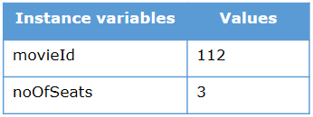
Output
Input
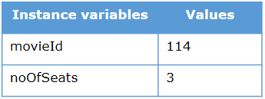
Output

String Questions :
29) Complete the removeWhiteSpaces() method given in the Tester class.
Method Description
removeWhiteSpaces(String str)
- Remove all the white spaces from the string passed to the method and return the modified string.
Test the functionalities using the main() method of the Tester class.

Sample Input and Output
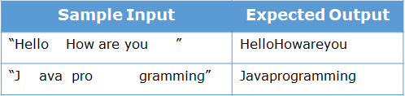

30 )Complete the moveSpecialCharacters() method given in the Tester class.
Method Description
moveSpecialCharacters(String str)
- Move all the special characters present in the string passed to the method to the end of the string and return the modified string.
Note: Assume that the input string does not have any space.
Test the functionalities using the main() method of the Tester class.

Sample Input and Output
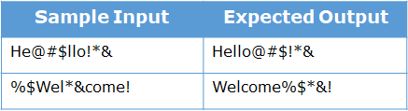
31) Complete the checkPalindrome() method given in the Tester class.
Method Description
checkPalindrome(String str)
- Check whether the string passed to the method is a palindrome or not.
- Return true if the string is palindrome, else return false.
Test the functionalities using the main() method of the Tester class.

Sample Input and Output
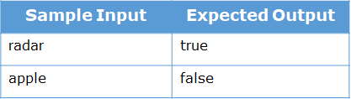
32)
Complete the reverseEachWord() method given in the Tester class.
Method Description
reverseEachWord(String str)
- Reverse each word in the string passed to the method without changing the order of the words and return the modified string.
Test the functionalities using the main() method of the Tester class.
Note: There should not be any extra blank/white space(s) in the output string.
Sample Input and Output
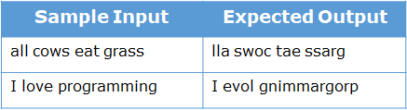

Array:
33)
Calculate and return the sum of all the even numbers present in the numbers array passed to the method calculateSumOfEvenNumbers. Implement the logic inside calculateSumOfEvenNumbers() method.
Test the functionalities using the main() method of the Tester class.

Sample Input and Output
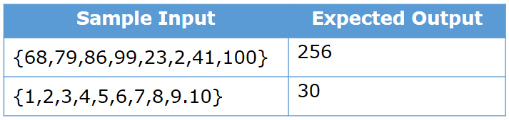

34) Implement the class Teacher based on the class diagram and description given below.
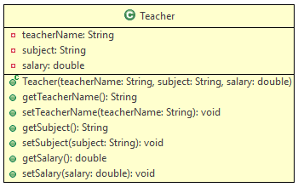
Method Description
Teacher(String teacherName, String subject, double salary)
Initialize the values of all the instance variables appropriately with the values passed
Create a Tester class. Create 4 objects of Teacher class. Create an array of type Teacher store the created objects and display the details of the teachers.

Sample Input and Output
Input
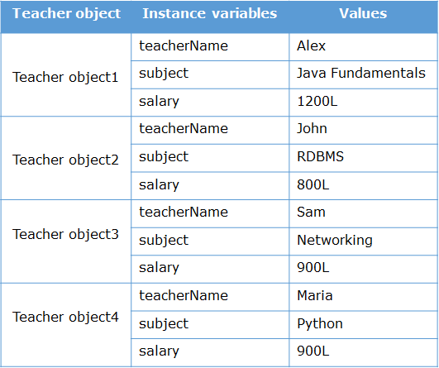
Output
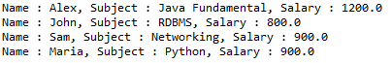

35) Find and return the average salary, number of salaries greater than the average salary and number of salaries lesser than the average salary from the salary array passed to the findDetails() method. Return a double array containing average salary in index position 0, number of salaries greater than the average salary in index position 1 and number of salaries lesser than the average salary in index position 2. Implement the logic inside findDetails() method.
Test the functionalities using the main method of the Tester class.

Sample Input and Output
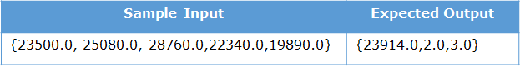
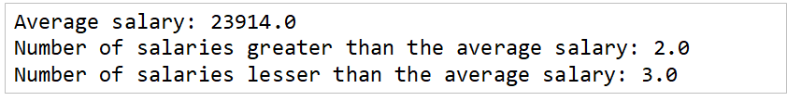
36) Implement the method findNumbers accepting two numbers num1 and num2 based on the conditions given below:
- Validate that num1 should be less than num2
- If the validations are successful
  - populate all the 2 digit positive numbers between num1 and num2 into the provided numbers array if
    - sum of the digits of the number is a multiple of 3
    - number is a multiple of 5
- Return the numbers array
Test the functionalities using the main method of the Tester class.

Sample Input and Output
Input
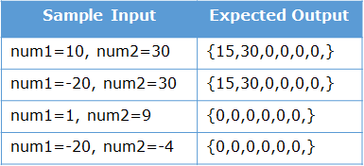
Output
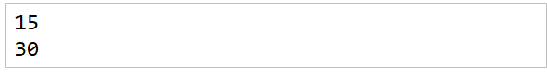
Static :
37) Implement the class Bill based on the class diagram and description given below.
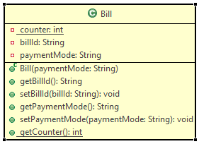
Method Description
Bill(String paymentMode)
- Initialize the paymentMode instance variable with the value passed to the parameter.
- Generate the billId using counter. The value of billId should start from 'B9001' and the numerical part should be incremented by 1 for the subsequent values. Initialize the counter in static block.
Implement the appropriate getter and setter methods.

Test the functionalities using the provided Tester class. Create two or more Bill objects and validate that the billId is being generated properly.
Sample Input and Output
For constructor
Input
For first Bill object
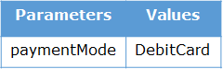
For second Bill object
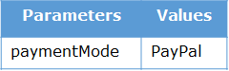
Output
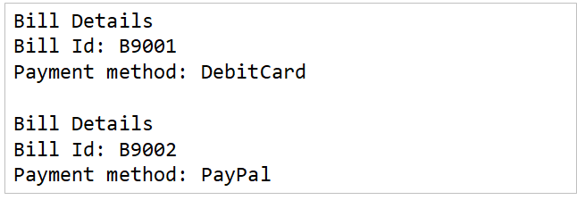
38) Problem Statement
You have already created the Order class in the SwiftFood project (Refer: Methods - Assignment 1).
Modify the Order class according to the class diagram given below. ()
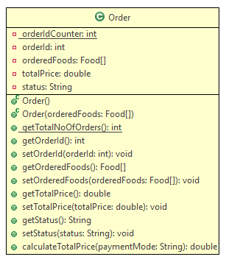
Method Description
Order(Food[] orderedFoods)
- Initialize the orderedFoods instance variable appropriately with the value passed to the constructor.
- Generate the orderId using orderIdCounter. The value of orderId should start from 101 and should be incremented by 1 for the subsequent values. Initialize the orderIdCounter in static block.
39) Problem Statement
Rainbow Cinemas is an upcoming multiplex in the city with a seating capacity of 400 people. They need an application to be developed for booking of tickets.
You need to implement a Booking class based on the class diagram and description given below.
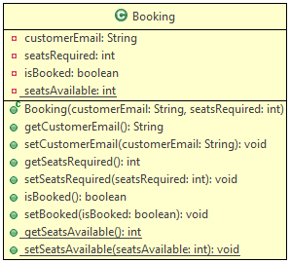
Method Description
Booking(String customerEmail, int seatsRequired)
- Initialize the customerEmail and seatsRequired instance variable appropriately with the values passed to the constructor.
- If the required number of seats are available, set the value of isBooked to true and update the value of seatsAvailable accordingly. The total number of seats available is 400 and should be initialized in static block.
- If the required number of seats are not available, set the value of isBooked to false.
Implement the appropriate getter and setter methods.
Test the functionalities using the provided Tester class. Create two or more Booking objects and validate that the values of the member variables are proper.

Sample Input and Output
For constructor
Input
For first Booking object
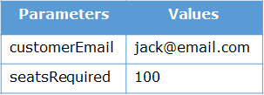
For second Booking object
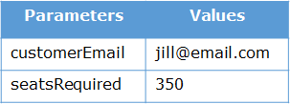
Output
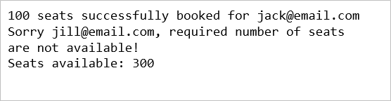

getTotalNoOfOrders()
- Return the total number of orders placed
Implement the appropriate getter and setter methods.

Inheritance:
39)
two classes - Camera and Digital Camera are provided to you.
Though the object of DigitalCamera class is being created with values as 'Canon' and 100 in the main method of Tester class, the code given below generates the following output.

Make the necessary changes in the code such that the member variables are initialized with proper values and the output is generated as follows:
Output
40)
A construction company wants to keep a record of the employees working in it. There are permanent employees as well as contract employees. Contract employees work on an hourly basis whereas permanent employees are paid monthly salary. An application needs to be developed for the company for storing the employee details.
Implement the classes based on the class diagram and description given below.
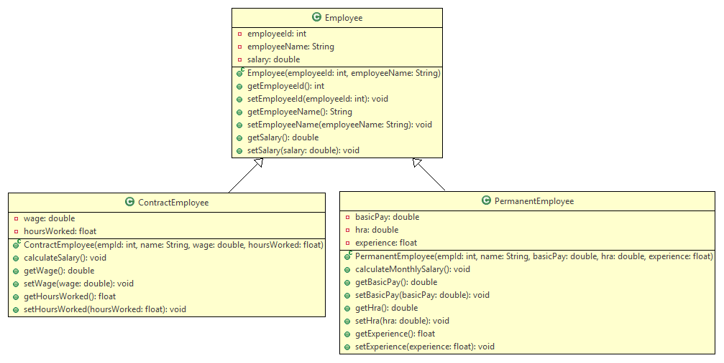
Method Description
Employee
Employee(int employeeId, String employeeName)
- Initialize the employeeId and employeeName instance variables appropriately with the values passed to the constructor.
Implement the getter and setter methods appropriately.
PermanentEmployee
PermanentEmployee(int empId, String name, double basicPay, double hra, float experience)
- Initialize the employeeId, employeeName, basicPay, hra and experience instance variables appropriately with the values passed to the constructor.
calculateMonthlySalary()
- Calculate and set the salary of the employee using the formula given below.
salary = basic pay + hra + variable component
- Variable component is calculated based on the employee's experience according to the table given below.
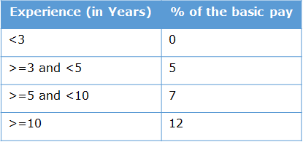
Implement the getter and setter methods appropriately.
ContractEmployee
ContractEmployee(int empId, String name, double wage, float hoursWorked)
- Initialize the employeeId, employeeName, wage and hoursWorked instance variables appropriately with the values passed to the constructor.
calculateSalary()
- Calculate the salary of the employee using the formula given below.
salary = hoursWorked * wage
Implement the getter and setter methods appropriately.

Test the functionalities using the provided Tester class.
Input and Output
For PermanentEmployee
Input
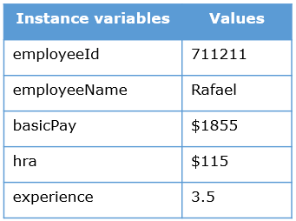
Output
For ContractEmployee
Input
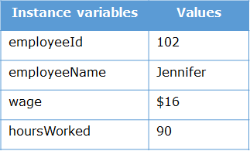
Output

41)Method Overloading :
The Point class is used for representing a point with two coordinates.
Implement the class Point based on the class diagram and description given below.
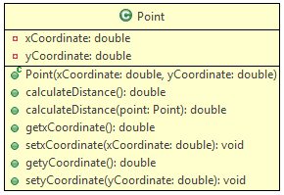

Method Description
Point(double xCoordinate , double yCoordinate )
- Initialize the instance variables xCoordinate and yCoordinate appropriately with the values passed to the constructor.
calculateDistance()
- Calculate and return the distance of the point from the origin (0,0). The distance can be calculated using the formula given below. The distance should be rounded off to 2 decimal digits.
distance=√((x2-x1)²+(y2-y1)²), where x1 and x2 are values of x-coordinates of two points and y1 and y2 are values of y-coordinates of two points
calculateDistance(Point point)
- Calculate and return the distance of the point from the 'point' passed to the method. The distance should be rounded off to 2 decimal digits.
Hints
- Use Math.sqrt(double d) method to calculate the square root
- Use Math.round(double d) method to round off the values
Implement the getter and setter methods appropriately.

Test the functionalities using the provided Tester class.
Sample Input and Output
Input
Point object - point1
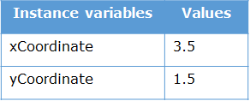
Point object - point2
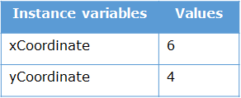
Output
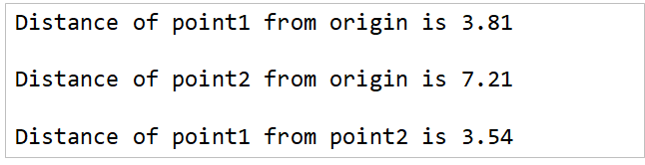
42) The Bill class is used to find the price of items for calculation. Implement a class Bill based on the class diagram and description given below.
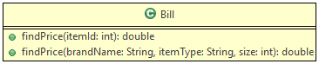
The details of the items are given below.
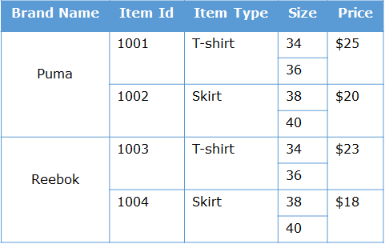
Method Description
findPrice(int itemId)
- Find and return the price based on the itemId using the table given above.
- If the itemId passed to method is invalid, return the price as 0.
findPrice(String brandName, String itemType, int size)
- Find and return the price based on the brandName, itemType and size using the table given above.
- If any invalid details are passed to the method, return the price as 0.

Test the functionalities using the provided Tester class.
Sample Input and Output
For findPrice(int itemId)
Input
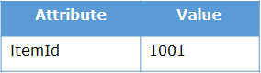

Output

For findPrice(String brandName, String itemType, int size)
Input
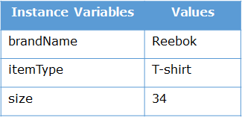

Output
Method Overriding
43) EPay Wallet is a wallet application using which users can pay various bills. Users can make payments only if they have enough wallet balance.
There are two kinds of users – User and PremiumUser. PremiumUser gets reward points for every payment.
Implement the classes based on the class diagram and description given below.
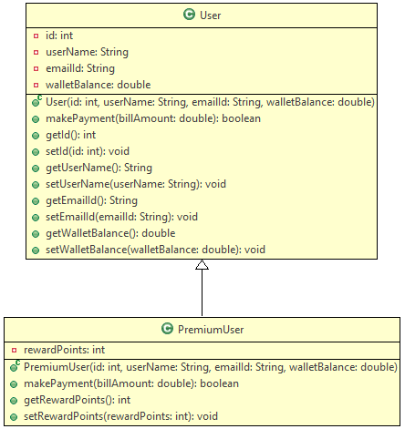
Method Description
User
User(int id, string userName, String emailId, double walletBalance)
- Initialize the instance variables with the values passed to the constructor.
makePayment(double billAmount)
- Make the payment by deducting the billAmount from walletBalance if and only if sufficient walletBalance is available.
- Return true if the payment is successful
- Return false if the walletBalance is insuffcient
Implement the appropriate getter and setter methods.
PremiumUser
PremiumUser(int id, string userName, String emailId, double walletBalance)
- Initialize the instance variables with the values passed to the constructor.
makePayment(double billAmount)
- Override the parent method to make payment as well as to credit reward points to the user.
- If the payment is successful, add 10% of the billAmount as rewardPoints
- Return true if the payment is successful, else return false
Implement the appropriate getter and setter methods.

Test the functionalities using the provided Tester class.
Sample Input and Output
Input
User object
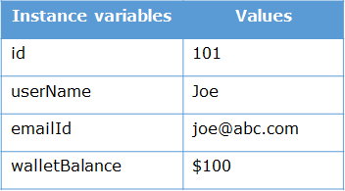
PremiumUser object
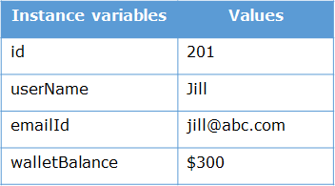
Payments made
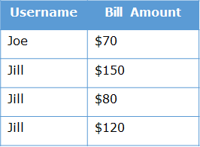
Output
